**Chapter 6**

**Improvements of EPCglobal C1 G2**

EPCglobal C1 G2 is the most renowned UHF RFID standard. It allows only for a single tag acknowledgment, even if the physical layer is able to identify multiple collided tags. This results in an overall reduced performance. Recent studies have focused on this problem e.g. [94] used the post-preamble proposed in [96] with a Multi Input Multi Output (MIMO) receiver to resolve collisions. The authors assumed that all the recovered tags can be acknowledged in par- allel. However, this technique is not compatible with the EPCglobal C1 G2 standards [11], due to this post-preamble. Therefore, their proposal requires a new RFID standard. Furthermore, acknowledging more than one tag in parallel would cause a new problem called “tag collision” due to the simultaneous recep- tion of multiple Acknowledgment “ACK” commands at the tag side. Moreover, this parallel acknowledgment will also cause Electronic Product Code (EPC) collisions at the reader side. The EPC packet is much longer than the *RN* 16 packet, so it needs an advanced collision recovery algorithm, which will decrease the system performance.

To overcome these pitfalls, this chapter proposes a system that is capable of acknowledging multiple tags within a single slot, resulting in a significant increase in performance. The main advantage of this proposal is that it is compatible with existing EPCglobal C1 G2 tags and readers. Hence, our improved tags can be read by conventional readers without affecting the performance. Furthermore, existing tags can be read simultaneously with our improved tags by

89

|  |  |  |
| --- | --- | --- |
|  |  |  |



Figure 6.1: Conventional tag response



Optimized readers.

This chapter is organized as follows: Section 1 presents a brief discussion about the conventional reading process using the EPCglobal C1 G2 standards. In section 2, we describe the proposed new system including the modifications of the tags and the reader. The performance of the proposed system will be analyzed in section 3. Finally, section 4 provides the practical measurements and the simulation results.

# EPCglobal C1 G2 Reading Process

This section will describe the conventional reading algorithm of the EPCglobal C1 G2 standards. The reader initially powers the tags in the reading area with a Continuous Wave (CW). At this time, the powered tags are in the ready state waiting for the frame length information from the reader. Then, the reader broadcasts the frame length and notifies all tags with the beginning of a new frame with a “Query” command. As soon as the tags receive this command, each tag selects a slot from the frame by setting its slot counter, and enters the “Arbitrate” state. When the tag’s slot counter is equal to zero, the tag enters the “Reply” state and tarts back-scattering its 16 bits Random Number (*RN* 16) as a temporary ID in addition to a 18 bits pilot and preamble used for synchronization as shown in Figure 6.1.

According to Frame Slotted ALOHA, there are three probabilities for each slot: Empty slot, Successful slot, and Collided slot.  
Empty slot: In such a slot, no tag has selected this slot to transmit its information in it. The reader transmits a “Query-Rep” command asking the tags to decrements their slot counters.   
Successful slot: In this slot, only one tag selects this slot to transmit its information in it. The reader transmits an “ACK” command including the received *RN* 16. Then, the acknowledged tag enters the “Acknowledged” state and replies with its permanent Electronic Product Coder “EPC” code. Collided slot: In such slots, the reader receives

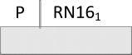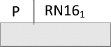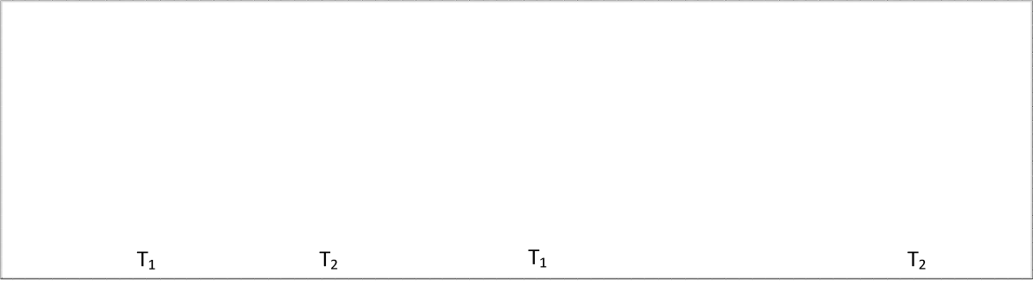

Figure 6.2: Example of two tags collided slot according to EPCglobal C1 G2 standard

simultaneously multiple replies from different tags. In this case, there are two possibilities:

* + 1. Systems have no collision recovery capability: In such systems, the reader fails to identify any *RN* 16, so it queries the next slot by sending another “Query-Rep” command. As soon as the collided tags receive the “Query- Rep” command, they enter the “Arbitrate” state waiting for the next frame. The maximum reading efficiency in such systems is 36%, when the working frame length is equal to the remaining number of tags in the reading area.
    2. Systems have collision recovery capability: They have the ability to iden- tify one *RN* 16 from the collided ones. Then, the reader broadcasts an “ACK” command including the identified *RN* 16. The tag which has the same *RN* 16 replies its “EPC” code and mutes itself until the end of the reading process. However, the remaining tags forget their *RN* 16*s* and en- ter the “Arbitrate” state waiting for the next frame. The main drawback of such systems is that the reader can only acknowledge one tag from the collided tags in a slot, even if it has the capability to identify all the responding *RN* 16*s*. To overcome this drawback, backwards compatible extension are proposed in the following sections.

Figure 6.2 presents an example for a collided slot with two collided tags. It shows the differences between the conventional systems without collision recov- ery and with collision recovery capability. According to Figure 6.2, the reader, which has no collision recovery capability couldn’t identify any of the two col-

lided *RN* 16*s*. However, the reader, which has collision recovery capability identified *RN* 161 and acknowledged the corresponding tag.

# Proposed System Description

In this section, the description of the proposed tags and readers will be pre- sented. Afterwards, the performance of the proposed system will be compared to the conventional systems. The proposed system has the same hardware of the conventional system. The main difference between the proposed system and the conventional one is the signal format between the new reader and the new tags.

## Proposed Tag

The proposed tags have the ability to act like conventional UHF EPCglobal C1 G2 tags, which is the default mode. However, it loads extra properties when it is in the ready state and receives a new command called “Switch” command from the proposed reader. The following part presents the main modifications in the signal format of the proposed tag:

According to the EPCglobal C1 G2 standards [11], conventional tags backscat- ter two possible preambles with the *RN* 16 packet: The condensed version with 6 bits preamble and the long version 18 bits (12 bits zeros as a pilot + 6 bit of the

condensed version). The proposed tags have only the long version, but with a new structure. Figure 6.3 presents the new structure of the *RN* 16 packet. As shown in Figure 6.3, the new structure has the identical 6 bits of the long conventional long pilot. However, the 12 bits zeros of the conventional long pilot are divided to two parts. The first part with 4 bits zeros used for synchronization and the second part with 8 bits orthogonal pilots used for channel estimation. Table 6.1 shows an example of the orthogonal pilots, which are similar to the orthogonal post-preamble used in [96]. The 8 orthogonal pilot bits have to be orthogonal to the other pilot bits and also to the conventional pattern *P*1 (8 zero bits). This property gives our proposal the advantage to have the conventional long version tag reply as a valid tag response in the new system. This is in contrast to the proposal by [96], where the conventional tags are not compatible with

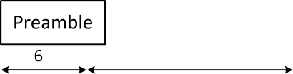

Figure 6.3: Tag response of the proposed tags including the new pilot sequences

Table 6.1: Set of 8 orthogonal sequences [96]

|  |  |
| --- | --- |
| Sequence | Orthogonal Pilots |
| *P*1 | 1 -1 1 -1 1 -1 1 -1 1 -1 1 -1 1 -1 1 -1 |
| *P*18 | 1 -1 1 -1 1 -1 1 1 -1 1 -1 1 -1 1 -1 -1 |
| *P*69 | 1 -1 1 1 -1 1 -1 1 -1 1 -1 -1 1 -1 1 -1 |
| *P*86 | 1 -1 1 1 -1 1 -1 -1 1 -1 1 1 -1 1 -1 -1 |
| *P*171 | 1 1 -1 1 -1 -1 1 -1 1 1 -1 1 -1 -1 1 -1 |
| *P*188 | 1 1 -1 1 -1 -1 1 1 -1 -1 1 -1 1 1 -1 -1 |
| *P*239 | 1 1 -1 -1 1 1 -1 1 -1 -1 1 1 -1 -1 1 -1 |
| *P*256 | 1 1 -1 -1 1 1 -1 -1 1 1 -1 -1 1 1 -1 -1 |

their system.

In case of a resolved collision of multiple *RN* 16*s*, the proposed pseudo par- allel reading process is applied. A tag receiving its valid *RN* 16 replies with its EPC and goes to the “Acknowledged” state. In contrast, a tag receiving an in- valid *RN* 16 (e.g. valid for another tag) goes to a new state called “Wait” state. In the latter state the tag memorizes its *RN* 16 until one of the two possibilities occurs: a) receiving an “ACK” command containing its *RN* 16. In this case the tag replies with its EPC and goes to the “Acknowledged” state, b) receiving the “ACK” command with wrong *RN* 16. In this case, the tag remains in the “Wait” state waiting for a new command.

Figure 6.4 presents a state diagram with the required modifications of the tag state diagram given in [11] on page 47 Figure 6.19.

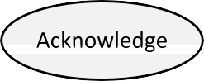

Figure 6.4: Modified part of the proposed tag’s state diagram

## Proposed Reader

The proposed reader applies the normal FSA based on the conventional UHF EPCglobal C1 G2 standard, which means that it is able to operate normally with conventional tags. However, it starts the reading process with a new com- mand called “Switch” command to switch the new tags from the conventional mode to the new mode. It should be transmitted before the “Query” command. The conventional tags will consider the “Switch” command as an unknown com- mand, but the proposed tags will recognize that they are working in the new system. Table 6.2 provides an example for the Switch command code, which is a16 bits command from the future use part of EPCglobal C1 G2 standards (*cf.* table 6.18 of [11]).

As discussed before, EPCglobal C1G2 standards can’t acknowledge more than one tag per slot. On the other hand, the proposed system should benefit from the collision resolving capabilities of the modern readers. Therefore, the proposed reader has the capability of converting the collided slot into a pseudo parallel successful slot as shown in Figure 6.5.

The reader starts each slot with a “Query-Rep” command asking for the

*RN* 16 of each tag. Then, each tag transmits its *RN* 16 including one random orthogonal pilot from table 6.1. In case of a collided slot, the reader executes the following steps:

* + - * The reader uses the orthogonal pilots to do channel estimation for the

Table 6.2: Switch command to switch the proposed tags from the conventional mode to the new mode



|  |  |
| --- | --- |
|  | Command |
| Number of bits | 16 |
| Description | 1110001001100000 |

|  |  |  |  |
| --- | --- | --- | --- |
|  | 1 |  | Rsol |

s(a)

s(b)

 

Figure 6.5: Example of the proposed pseudo parallel successful slot with parallel Query command and RN16 followed by successive Acknowledgment commands and EPCs

collided tags. Afterwards, it employs the channel information to recover the collided RN16s using a MIMO receiver, e.g. the receiver proposed in [94].

* + - * + The reader counts the number of recovered *RN* 16*s* replies in the “Reply Counter”.
        + The reader recognizes whether one of these replies is a conventional pilot or not by checking if one of the collided pilots is *P*1(the conventional one) in Table 6.1. If yes, the reader considers it as conventional tag.

Afterwards, the reader starts acknowledging the collided tags successively or- dering them from the weakest to the strongest reply. The “Reply Counter” counts down with each received EPC from a tag. Then, it sends successive “Acknowledgment” commands until the “Reply Counter” reaches zero. Figure

Reader Tag

Switch all the new tags to the new mode



Resolves the 3 RN16s Replies Counter=3 Sends “ACK“ command to tag1

Replies Counter=2  Sends “ACK“

command to tag2

3 tags collided slots “Reply“ state

Tag1 is in “Acknowledged“ state Tag1 replies with its EPC1

Tag2,3 are in “Waiting “state

Replies Counter=1  Sends “ACK“

command to tag3

Tag2 is in “Acknowledged“ state Tag2 replies with its EPC2

Tag3 is in “Waiting “state

Replies Counter=0 Starts next slot

Tag3 is in “Acknowledged“ state Tag3 replies with its EPC3

Time

Figure 6.6: Example of an inventory round using the proposed reader and 3 collided tags

*6.3. PERFORMANCE ANALYSIS* 97

6.6 illustrates an example for a complete inventory round between the proposed reader and 3 collided tags. According to Figure 6.6, the reader stated the inven- tory round with a “Switch” command. The 3 tags switched to the new mode. Then the reader sent a “Query” command to the tags asking them for their *RN* 16*s*. The 3 tags replied with their *RN* 16*s* at the first slot and produced collided slot. The reader applied have identified the 3tags in a pseudo parallel slot.

# 6.3 Performance Analysis

In the conventional DFSA, the reading efficiency is the probability of single tag reply *P* (*R* = 1). where *P* (*R*) is the probability that exactly *R* tags are active in one slot. It can be presented as:

(*n*\ ( 1 *R* (

*P* (*R*) =

1 *− L*

*R*

*L*

1 *n−R*

*R*

*L*

Thus, the reading efficiency of the conventional system is presented as:

(6.1)

*ηconv* =

( *n* \ (

*L*

1 *n−*1

*− L*

\1

(6.2)

In the proposed system, the reader has the capability to resolve up to *M*

collided tags. Therefore, the proposed reading efficiency can be presented as:

*M*

*·*

*ηproposed* = *P* (*R*) *Rsol* (6.3)

*R*=1

For the proposed case, *M* = 8 is the number of orthogonal codes which are presented in table 6.1. *Rsol* is the number of recovered tags.

Since the collision recovery capability of the proposed system depends on the pilot of the replied tags. For the proposed case, the unique scenarios (1 +

1 + *...* + 1) are only considered, i.e. if more than one tag has the same pilot, the reader will not be able to resolve this collision. Therefore, we have limited number of scenarios. Thus, equation 6.4 considers the effect of the unique scenarios

*M R*

*ηproposed* = *P* (*R*) *· Rsol · PSl* (*R*) (6.4)

*R*=1

*l*=1

Table 6.3: Example for unique pilot collision scenarios for up to eight colliding tags per slot [94]

|  |  |
| --- | --- |
| Number of received tags *R* | Probability of unique scenario *Ps*1 |
| 1 | *PS*1 = 1 |
| 2  1+1 | *PS*1 = 0*.*875 |
| 3  1+1+1 | *PS*1 = 0*.*656 |
| 4  1+1+1+1 | *PS*1 = 0*.*41 |
| 5  1+1+1+1+1 | *PS*1 = 0*.*205 |
| 6  1+1+1+1+1+1 | *PS*1 = 0*.*077 |
| 7  1+1+1+1+1+1+1 | *PS*1 = 0*.*019 |
| 8  1+1+1+1+1+1+1+1 | *PS*1 = 0*.*002 |

where *PS* (*R*) represents the probability that scenario *Sl* happens. It can be calculated from the binomial distribution as explained in [94].Table 6.3 shows all values of the unique scenarios *PS* (*R*).

*l*

*l*

For the proposed case, the system can’t acknowledge the recovered tags in parallel. It uses the discussed pseudo parallel method. According to Figure 6.5, the conventional successful slot *ts* is divided in to two parts: The first part presents the “Query-Rep” command and the *RN* 16 tag reply *ts*(*a*). The second part is the “ACK” command and the EPC tag reply *ts*(*b*). Thus, the successful slot time is:

*ts* = *ts*(*a*) + *ts*(*b*)*,* (6.5)

where *ts*(*a*) and *ts*(*b*) can be expressed as:

(6.6)

|  |  |  |
| --- | --- | --- |
| *ts*(*a*) | = | *TqRep* + *T*1 + *T*2 + *TRN* 16 |
| *ts*(*b*) | = | *TACK* + *T*1 + *T*2 + *TEP C* |

Table 6.4 shows numerical values from the EPCglobal C1 G2 standards [11] as a function of the link pulse-repetition interval *Tpri*. According to these values, the time of the Query-Rep command and receiving the RN16s presents 30% of the conventional successful slot duration. The time of the acknowledgment command and the EPC tag reply represents 70% of the conventional successful slot duration.

In the proposed system, the reader sends a Query command in parallel to all the tags and receives the *RN* 16*s* in parallel. Then, the reader sends successive “ACK” commands to the resolved tags. Therefore, the duration of the proposed pseudo parallel slot is:

*tpseudo* = *ts*(*a*) + *Rsol · ts*(*b*)*,* (6.7)

where *Rsol* is the number of recovered tags. These tags are acknowledged succes- sively. Therefore, the proposed efficiency should include a factor representing the effect of the pseudo parallel spreading in time. This factor is called the pseudo parallel factor *ϕ*. According to the numerical values in Table 6.4, it can be expressed as:

*ϕ* = ( 0*.*3 +

1

0*.*7 *· Rsol*

\ (6.8)

Based on the above discussion, the proposed reading efficiency formula con- sidering the advantages of the new system is formulated as:

*ηproposed* =

*M*

*R* =1

*P* (*R*) *·*

*R*

*l*=1

(

*PSl* (*R*) *· Rsol · ϕ*\

*,* (6.9)

# Measurement and Simulation Results

The proposed tag’s signal modifications are implemented on the Wireless Iden- tification Sensing Platform (WISP 5.0) [97], and the proposed reader modi-

0.8

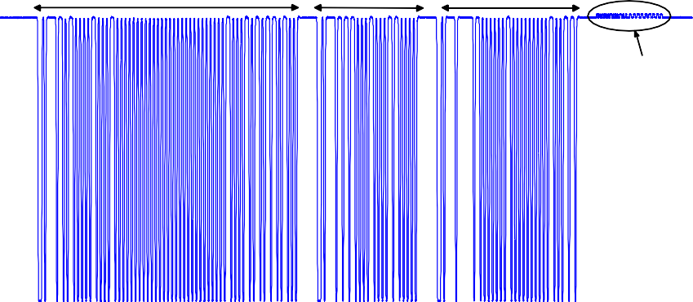

Select Command

Switch Command Query Command

Tag Reply

0.7

0.6

Amplitude

0.5

0.4

0.3

0.2

0.1

3.0888 3.0918 3.0948 3.0978 3.1008 3.1038 3.1059

Number of samples

* + 1. Proposed reader to tag communication link

6

x 10

0.79

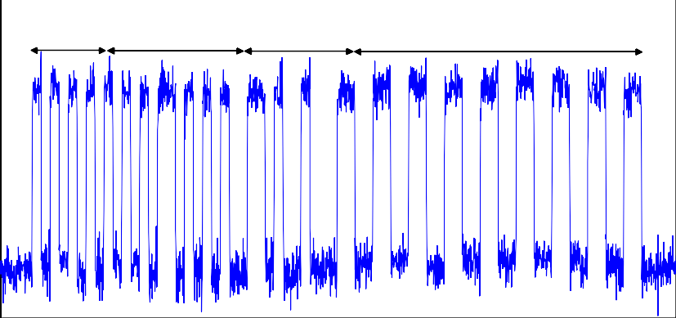

Sync.

Pilot (P18) Preamble

RN16

0.788

0.786

Amplitude

0.784

0.782

0.78

0.778

0.776

3.1036 3.1038 3.104 3.1042 3.1044 3.1046 3.1048 3.105 3.1052

Number of Samples

(b) Proposed tag reply

Figure 6.7: Communication link measurement

6

X 10

Table 6.4: System Parameters of EPCglobal C1 G2 standards [11]

|  |  |
| --- | --- |
| Parameters | Values |
| *TQ−Rep* | 78 *Tpri* |
| *T*1 | 10 *Tpri* |
| *T*2 | 20 *Tpri* |
| *TRN* 16 | 34 *Tpri* |
| *TACK* | 236 *Tpri* |
| *TEP C* | 102 *Tpri* |

220

200

Average reading Efficiency ( ) %

180

160

140

120

100

80

60

40

20

0

0 0.2 0.4 0.6 0.8 1 1.2 1.4 1.6 1.8 2 2.2 2.4 2.6 2.8 3

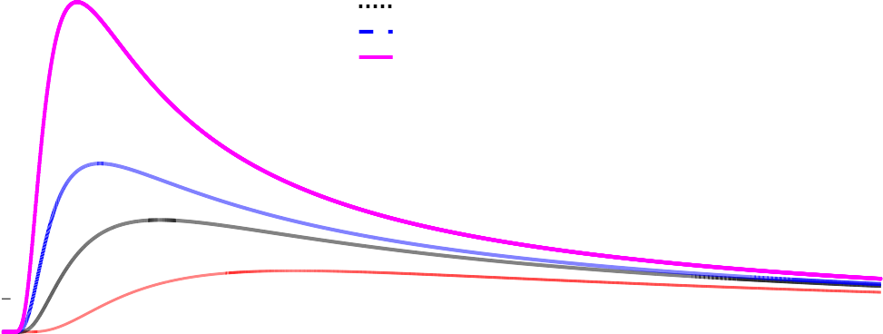

Conventional FSA Single acknowledgment

Proposed pseudo parallel acknowledgment Fully parallel acknowledgment (Not applicable in practice)

L/n

Figure 6.8: Reading efficiency for the conventional FSA and different acknowl- edgment scenarios using 8-orthogonal pilots

fications are implemented on the Universal Software Radio Peripheral (USRP B210) [63]. Figure 6.7a provides a measurement of the envelop signal for reader to tag (down link) communication. According to figure 6.7a, the reader starts with a normal “Select” command to set some conventional tag parameters. Then, the reader broadcasts the “Switch” command to make the existing tags switch to the new mode. The conventional tags will not recognize this com- mand, so they will simply ignore it. Afterwards, the reader sends the “Query” command asking the tags to reply with their *RN* 16*s*. Figure 6.7b presents the tag reply (up link) communication. As shown in Figure 6.7b, the proposed tag reply starts with 4 bits zeros used for synchronization followed by 8 bits (one of the orthogonal pilots in Table 6.1). In this example the tag replies with *P*18. It is followed by the 6 bits preamble. Finally, the tag backscatters its *RN* 16. The system is tested in a mixed network between the conventional and the pro- posed tags. The *RN* 16 of the conventional and proposed tags were identified successfully.

The performance analysis is achieved through Monte Carlo simulations. Fig- ure 6.8 shows a comparison between the reading efficiency of the conventional FSA and the different acknowledgment scenarios use the 8 orthogonal pilot se- quences. The first scenario is the fully parallel acknowledgment scenario, which is proposed by [94]. This system assumes fully parallel acknowledgment for all recovered tags. It results 200 % maximum reading efficiency. Which means

3000



Conventional FSA

C. Angerer

J. Kaitovic Proposed system Theoretical Limit

2500

Average Reading Time (Slots)

2000

1500

1000

500

0

0 100 200 300 400 500 600 700 800 900 1000

Number of Tags (n)

Figure 6.9: Comparison between the average reading time for different systems

that, 2 tags on average are identified per slot. However, this method is not compatible with the EPCglobal C1 G2 standard and can not be applied in practice, because it will produce collision in the tag side. The second scenario uses only single acknowledgment system. It acknowledges only a single tag and neglect the other tags replies. It results 67 % maximum reading efficiency. This system does not benefit from the strong collision recovery capability of the reader. The third one is the proposed pseudo parallel successful slot; this system compromises between the single tag acknowledgment and the fully parallel acknowledgment. It results 100% maximum reading efficiency. This means that it approaches the theoretical lower reading time limit of the EPCglobal C1 G2 standard [11].

Figure 6.9 shows the average reading time of the proposed system compared to the conventional FSA and other recent EPCglobal C1 G2 compatible systems using collision recovery techniques. According to Figure 6.9, the average reading time of the proposed system is decreased compared to the conventional FSA by 60%. In [81] the authors proposed a collision recovery system that is able to recover up to two collided tags. Accordingly, the average reading time of

the proposed system is lower than the reading time of [81] and [98] by 50% and 35%, respectively. Finally, the proposed system approaches the theoretical limit of the EPCglobal C1 G2 standards [11]. This gain is only attainable using the modified compatible tags. However, the proposed maximum performance using the conventional tags is presented in the results of chapter 5.